# Krugman, Obstfeld and Melitz, International Economics, 2012, Chapter 13

# Understanding Capital And Financial Accounts In The Balance Of Payments. By [Reem Heakal](http://www.investopedia.com/contributors/80/)

# What Is The Balance Of Payments? By [Reem Heakal](http://www.investopedia.com/contributors/80/)

-

ECO3702: Advanced Economy Macroeconomics Lecture Note 5.

2017

Mundell Fleming Model

Exchange Rate Regimes

**Kaan Öğüt**

# Krugman, Obstfeld and Melitz, International Economics, 2012, Chapter 18

Bahçeşehir unıversıty



FBAR: fixed but adjustable





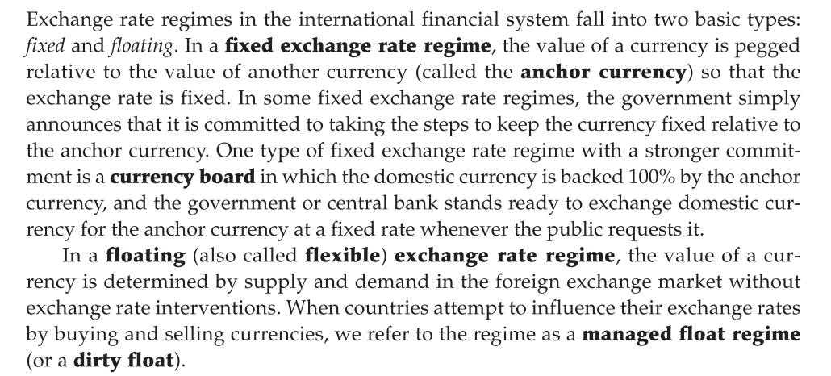

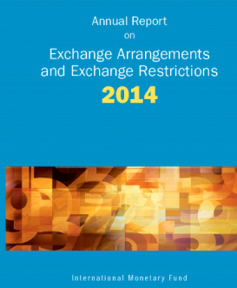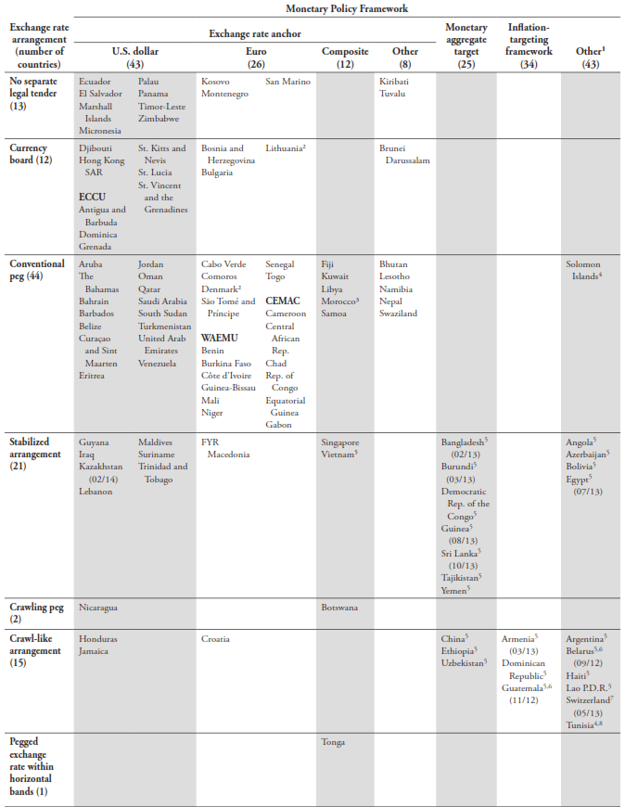

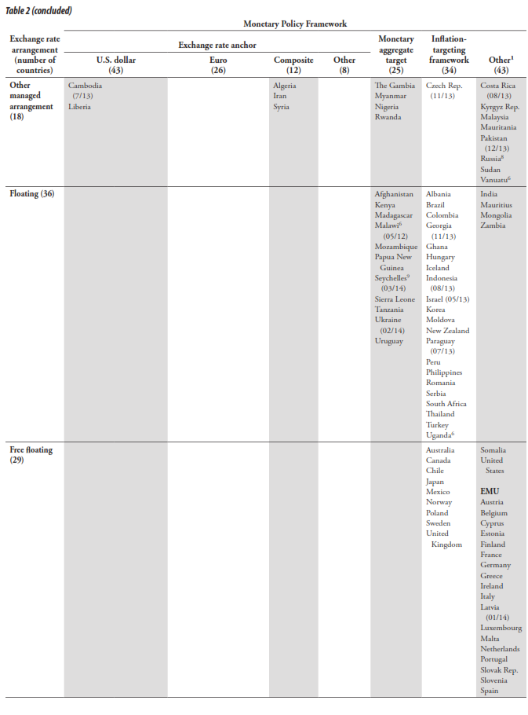

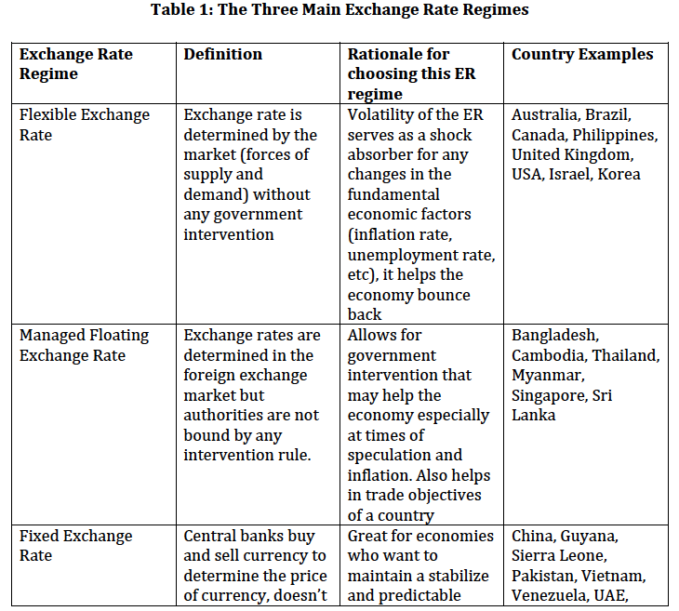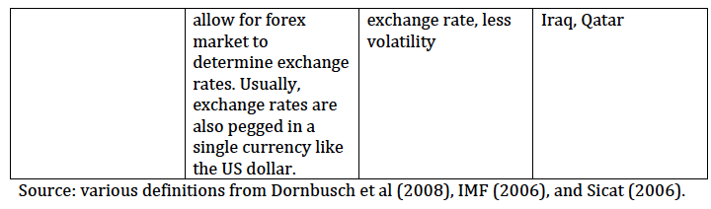

**Flexible – Floating Exchange Rate:**

If the exchange rate is *completely* ﬂexible, national monetary authorities do not trade in theforeign exchange market to inﬂuence exchange rates. Value of a currency is determined by supply and demand in foreign exchange market.



This zero balance is achieved by adjustment (movement) of the exchange (as an automatic stabilizer) rate under the flexible exchange rate regime.

If the balance of payment is in deficit it will lead to depreciation of the domestic currency.



If the balance of payment is in surplus it will lead to appreciation of the domestic currency[1]



If the balance is not exactly satisfied through the movements of exchange rate, central bank will intervene in the foreign exchange market. Otherwise exchange rate would be more fluctuating.

**A floating exchange rate regime allows a currency's value to fluctuate according to the foreign-exchange market**. One of the key arguments for this type of exchange rate mechanism is that monetary policy no longer needs to be focused on maintaining a country’s exchange rate at a given fixed level, and can be focused on other goals, such as encouraging an increased level of economic activity or containing inflation. **And the automatic adjustment of exchange rates can help to dampen the impact of the business cycle**, or of external shocks to an economy, in particular helping to reduce the risk of a balance of payments crisis. But floating exchange rates can also bring unpredictability, and occasional instability, if the movement in the currency – the appreciation or depreciation - is too great.

A free floating exchange rate brings an increased level of foreign exchange volatility, and this can sometimes cause serious problems, especially in emerging economies which are heavily reliant on trade. Another problem facing emerging economies is that they often have loans denominated in a foreign currency and so currency depreciation can cause rapid and severe deterioration in the balance sheets of banks, households and the corporate sector

**Floating exchange rate** 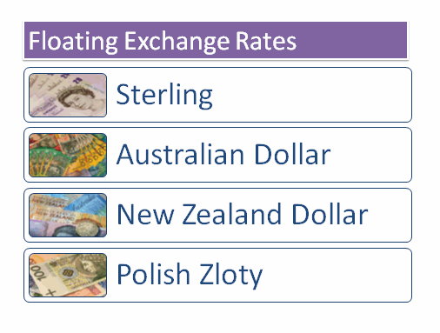When a country uses a floating exchange rate system:

* The value of the currency is determined purely by demand and supply of the currency  
* Trade flows and capital flows affect the exchange rate under a floating system  
* There is no target for the exchange rate and no intervention in the market by the central bank

Sterling has floated since the UK suspended membership of the ERM in September 1992. The Bank of England has not intervened to influence the pound’s   
value since it became independent.

**Fixed Exchange Rate:**

To fix the exchange rate, a central bank influences the quantities supplied and demanded of currency by trading domestic and foreign assets, so that the **exchange rate** (the price of foreign currency in terms of domestic currency) **stays constant**.

Central Bank announces a fixed exchange rate for the currency.



**Under a complete fixed exchange rate regime, the central bank has to defend the committed parity with, purchases or sales of foreign exchange**. These buying and selling actions cause to change in international reserves of the CB.



Balance of payment surplus causes an increase in reserves and deficit causes a decrease in.

# Countries with Fixed Currency Exchange Rates

Feb 19, 2013

We’ve touched on the impact that currency risks can have on frontier market investments [before](https://www.investmentfrontier.com/2013/01/03/dont-forget-about-currency/), but countries with fixed exchange rates present a unique dilemma. On the one hand currencies are by definition stable, alleviating currency worries since FX volatility is near zero. On the other hand, they are susceptible to large one-off moves and de-peg risk. Investors in Venezuela experienced this firsthand last week when the country [devalued](http://www.ft.com/intl/cms/s/0/6cfdb6ae-7243-11e2-896a-00144feab49a.html) its currency by 32%, from 4.3 VEB to 6.3 VEB per USD.

We scoured the web for a good list of countries that still use fixed currency rates and were left wanting. Existing ones out there contain outdated information, or are filled with currencies of small countries that are irrelevant even to frontier investors. This is why we have compiled a list of all countries that still maintain fixed currency exchange rates and have populations over 1 million (with some exceptions). By our count there are 36 relevant countries in all, listed below for future reference.

Interestingly the majority of these countries are pegged to the EUR (17 total), with the USD coming second (13 total). This will make things extra interesting if the Euro is ever broken up since many of these are themselves in a monetary union (pegged to another monetary union).

Africa is home to most of the fixed currency countries at 19, with 14 of them using the CFA franc that is pegged to the Euro and three pegged to the South African Rand (ZAR) as part of a Common Monetary Area. The Middle East is another bastion for fixed currency rates, with 7 countries all pegged to the USD. Nepal is the only country pegged to the Indian rupee, which given the volatile status of INR has increased talk of breaking away from this peg.The full list of countries with fixed currency exchange rates, population greater than 1 million: (last updated Feb 2015)

|  |  |  |  |  |  |  |
| --- | --- | --- | --- | --- | --- | --- |
| **Country** | **Region** | **Ccy Name** | **Code** | **Peg Rate** | **Peg Ccy** | **Rate Since** |
| Bahrain | Middle East | Dinar | BHD | 0.376 | USD | 2001 |
| Benin | Africa | West African CFA Franc | XOF | 655.957 | EUR | 1999 |
| Bosnia and Herzegovina | Europe | Convertible Mark | BAM | 1.95583 | EUR | 2002 |
| Bulgaria | Europe | Lev | BGN | 1.95583 | EUR | 2002 |
| Burkina Faso | Africa | West African CFA Franc | XOF | 655.957 | EUR | 1999 |
| Cameroon | Africa | Central African CFA Franc | XAF | 655.957 | EUR | 1999 |
| Central African Republic | Africa | Central African CFA Franc | XAF | 655.957 | EUR | 1999 |
| Chad | Africa | Central African CFA Franc | XAF | 655.957 | EUR | 1999 |
| Cuba | Central America | Convertible Peso | CUC | 1 | USD | 2011 |
| Denmark | Europe | Krone | DKK | 7.46038 | EUR | 1999 |
| Dijibouti | Africa | Franc | DJF | 177.721 | USD | 1973 |
| Equatorial Guinea | Africa | Central African CFA Franc | XAF | 655.957 | EUR | 1999 |
| Eritrea | Africa | Nakfa | ERN | 15 | USD | 2005 |
| Gabon | Africa | Central African CFA Franc | XAF | 655.957 | EUR | 1999 |
| Guinea-Bissau | Africa | West African CFA Franc | XOF | 655.957 | EUR | 1999 |
| Hong Kong | Asia | Dollar | HKD | 7.75-7.85 | USD | 1998 |
| Ivory Coast | Africa | West African CFA Franc | XOF | 655.957 | EUR | 1999 |
| Jordan | Middle East | Dinar | JOD | 0.709 | USD | 1995 |
| Lebanon | Middle East | Pound | LBP | 1507.5 | USD | 1997 |
| Lesotho | Africa | Loti | LSL | 1 | ZAR | 1980 |
| Mali | Africa | West African CFA Franc | XOF | 655.957 | EUR | 1999 |
| Namibia | Africa | Dollar | NAD | 1 | ZAR | 1993 |
| Nepal | Asia | Rupee | NPR | 1.6 | INR | 1993 |
| Niger | Africa | West African CFA Franc | XOF | 655.957 | EUR | 1999 |
| Oman | Middle East | Rial | OMR | 0.3845 | USD | 1986 |
| Panama | Central America | Balboa | PAB | 1 | USD | 1904 |
| Qatar | Middle East | Riyal | QAR | 3.64 | USD | 2001 |
| Republic of the Congo | Africa | Central African CFA Franc | XAF | 655.957 | EUR | 1999 |
| Saudi Arabia | Middle East | Riyal | SAR | 3.75 | USD | 2003 |
| Senegal | Africa | West African CFA Franc | XOF | 655.957 | EUR | 1999 |
| Swaziland | Africa | Lilangeni | SZL | 1 | ZAR | 1974 |
| Togo | Africa | West African CFA Franc | XOF | 655.957 | EUR | 1999 |
| United Arab Emirates | Middle East | Dirham | AED | 3.6725 | USD | 1997 |
| Venezuela | South America | Bolivar | VEB | 6.3 | USD | 2013 |

**Competitive devaluations**

Competitive devaluations occur when a country deliberately intervenes in foreign exchange markets to drive down the value of their currency to provide a competitive boost to demand and jobs in their export industries. They may also try to do this when faced with the threats of a deflationary recession.

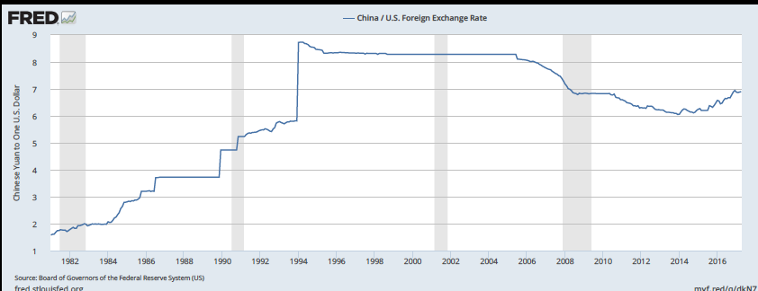



**Managed Floating Exchange Rate:**

However in reality, theassumption of complete exchange rate ﬂexibility and also fixed exchange rate regimes are rarely accurate. Industrialized countries now operate under a hybrid system of **managed ﬂoating exchange rates** a system in which **governments may** **attempt to moderate exchange rate movements** without keeping exchange rates rigidly ﬁxed.



Even if exchange rate has been determined by demand and supply forces in the foreign exchange market central bank try to mitigate the fluctuations in exchange rates.

**Central banks often intervene in currency markets to inﬂuence exchange rates.** So while the dollar exchange rates of the industrial countries’ currencies are not currently ﬁxed by governments, they are not always left to ﬂuctuate freely, either. The system of ﬂoating dollar exchange rates is often referred to as a dirty ﬂoat, to distinguish it from a clean ﬂoat in which governments make no direct attempts to inﬂuence foreign currency values.

In this lecture we study **how central banks intervene in the foreign exchange market to ﬁx or to manage exchange rates** and **how macroeconomic policies work** when exchange rates are ﬁxed or managed. The lecture will help us understand the role of central bank foreign exchange intervention in the determination of exchange rates under a system of managed ﬂoating.

Because the present exchange rate system is a hybrid of the “pure” ﬁxed and ﬂoating rate systems, an understanding of ﬁxed exchange rates gives us insight into the effects of foreign exchange intervention when it occurs under ﬂoating rates.

While industrial countries generally allow their currencies to float against the dolar, Many developing countries try to peg the values of their currencies, often in terms of the dollar, (sometimes in terms of a nondollar currency or some “basket” of currencies chosen by the authorities).



According to equation demand of foreign exchange of economy can be determined by capital flows, net exports, central bank actions (buying / selling) and **foreign currency demand of residents.** On the other hand it is difficult to observe the last component of the foreign currency demand so it has been ignored generally in the models.

**Foreign Exchange Deposits of Domestic Residents.**  **Exchange Rate USD/TL**

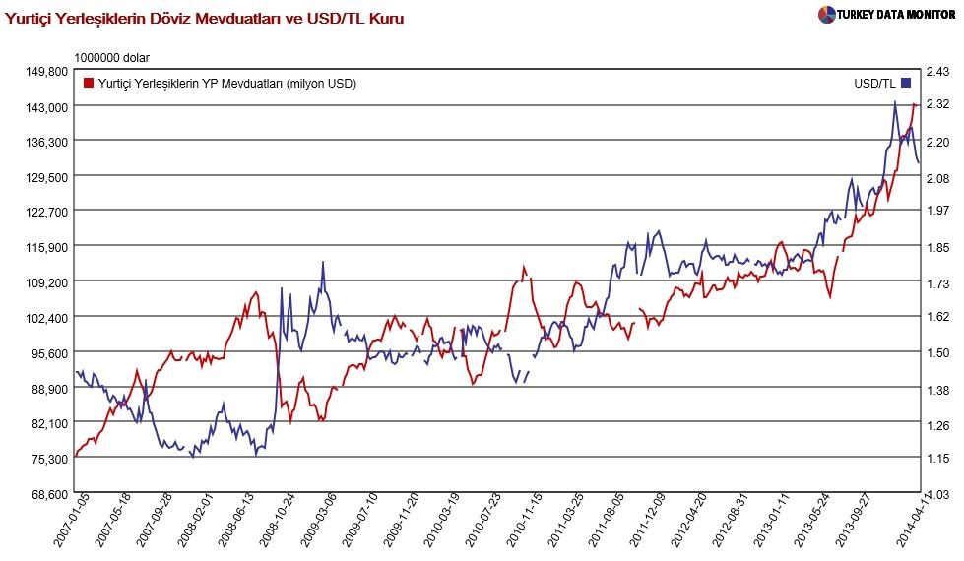

**Managed floating exchange rate**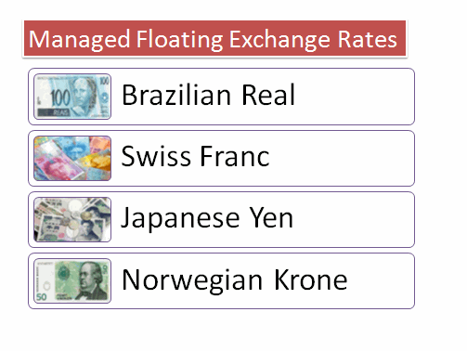

When a country uses a managed floating exchange rate system

* The value of a currency from day to day is determined by market demand for and supply of the currency  
* Some currency market intervention might be considered as part of demand management (e.g. a desire for a slightly lower currency to boost export demand)  
* Intervention can either be explicit i.e. a central bank buys foreign currency when it wants the domestic currency to depreciate  
* Intervention might come from changes in policy interest rates so as to affect the net flows of short term banking money (so-called “hot money”)  
* Verbal intervention is when a central bank tries to send a signal to the currency markets that it wishes the currency to move in a certain direction and that it stands by ready to engage in official market intervention if this does not happen

In 2012 a growing number of countries are moving towards managed or “dirty” floating systems. Brazil, Japan, Switzerland and Norway have all intervened in the currency markets in recent months.

Brazil in particular has claimed that developed nations are seeking to undervalue their currencies to create a competitive advantage in the world economy and kick-start their economies. They have introduced extra taxes on the interest paid on foreign deposits in their banking system.

August 19, 2014 2:00 pm JST

IMF finds more countries adopting managed floating exchange rate system

TOKYO -- More countries are adopting a managed floating exchange rate system, especially as **a number of emerging countries try to safeguard their currencies from increased volatility in foreign exchange markets triggered by monetary easing measures from advanced countries.**

     In 2013, **82 countries and regions used the system, or 43% of all countries**. This was up from 35% in 2009. This means more countries now use this system than do the floating exchange mechanism, according to a survey of 191 countries and regions by the International Monetary Fund.

     The managed floating system is equivalent to a middle ground between the floating system and the fixed system. China has adopted the managed floating mechanism, thereby limiting its currency moves to a certain range.

     The survey found that 65 of countries and regions, including industrialized nations such as Japan, the U.S. and many European countries, use the floating system, representing 34% of the total. This is down from the 2009 peak of 42%, or 79 countries and regions.

     A total of 25 countries and regions, including Hong Kong, use a fixed exchange rate system, in which their currencies are pegged to the U.S. dollar, according to the IMF.

     In 2012, Georgia, Papua New Guinea and several other countries switched to the managed floating system from the floating one. The IMF effectively categorizes Argentina under the managed floating system as it has conducted heavy currency interventions in recent years.

**Under the floating system, small economies are often subject to wild exchange rate swings due to a large influx and outflow of surplus money caused by monetary easing.**

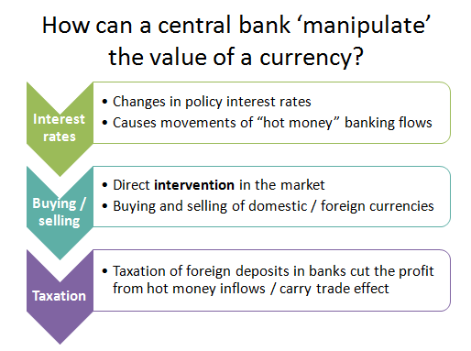

1. Probably capital inflow is sensitive to exchange rate movements, through the expected depreciation rate . It might be taken as another link between exchange rate and BP

   

  